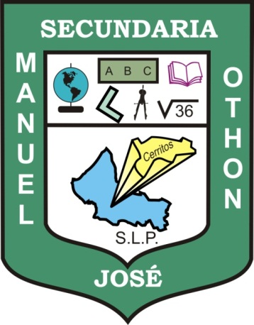
Escuela Secundaria General
“Manuel José Othón”

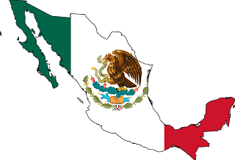
WORKBOOK
ENGLISH II

Teacher's name: JUAN MANUEL GUERRERO MARTÍNEZ
Student's name:
Grade: SECOND
Group:

Cerritos, S.L.P. August 19th, 2013

