ESCUELA SECUNDARIA GENERAL
“MANUEL JOSÉ OTHÓN”
EXAMEN DE CONOCIMIENTOS
LENGUA EXTRANJERA (INGLÉS) PRIMER GRADO TERCER BIMESTRE

NOMBRE DEL ALUMNO: _______________________________________________________
GRUPO: _________________________ ACIERTOS:_________________________________
*****************************************************************************
I.- WRITE SENTENCES ABOUT A LEISURE ACTIVITY, FOOD, DRINK AND SPORTS. YOU CAN USE THE WORDS OF THE BOX BUT YOU HAVE TO USE LIKE, HATE, LOVE, DON´T LIKE AND DOESN´T LIKE

FOOD AND DRINKS | LEISURE ACTIVITY | SPORTS
AVOCADO, BANANA ,BEEF, MELON, CHICKEN, HAMBURGUER | COLLECT: CARDS, STAMPS  GO: CAMPING, SHOPPING, TO THE MOVIES  LISTENING TO: MUSIC, RADIO  PLAY: A SPORT, AN INSTRUMENT, GAMES  WATCH: A MOVIE, A SPORT, A VIDEO | BASEBALL, BASKETBALL, BOXING, CYCLING, RUNNING, SOCCER
LIKE:

HATE:

LOVE:

( ) DON´T LIKE:

( ) DOESN´T LIKE:

II.- WRITE THE WORDS IN THE BOX IN THE APPROPRIATE CATEGORY
Movies camping video games sports shopping comics magazines the radio newspaper to parties music instruments TV camping books

WATCHING | GOING | LISTENING TO | READING | PLAYING

III.- FIND THE NAME OF 5 DIFFERENT SPORTS AND 5 DIFFERENT PLACE AND WRITE THE TRANSLATION INTO SPANISH IN FRONT OF THEM
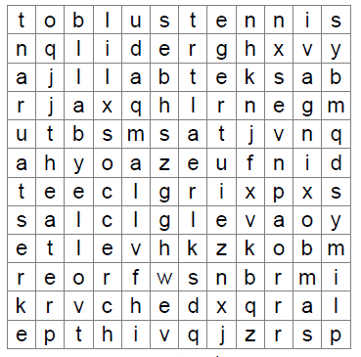
Mall
Movies
Park
Theater
Restaurant
Tennis
Soccer
Volleyball
Boxing
Basketball

IV.- WRITE DO OR DOES AS APPROPRIATE AND THE RIGHT ANSWER

1.-__________________ YOU LIKE SPANISH?
2.- __________________ YOU LIKE TO WEAR ANOTHER UNIFORM?
3.- __________________ ESMERALDA LOVE THE ENGLISH TEACHER?
4.- __________________ HE HATE THE ENGLISH SUBJET?
5.- __________________ PANCHO AND PANCHA LIKE READING LOVE STORIES?
6.- __________________MARIANITA LOVE SUSANA?

At one point in your life
you either have the thing
you want or the reasons
why you don't

En un momento en tu vida
o tienes lo que quieres
o las razones por las
que no lo hacen

